6.Write a python program to implement List methods (Add, Append, Extend & Delete).
Aim
To write a Python program to implement list methods such as add, append, extend, and delete.
Algorithm
- Start the program.
- Create a list with some elements.
- Add an element to the list using the insert() method.
- Append an element using the append() method.
- Add multiple elements using the extend() method.
- Delete an element using the del statement.
- Display the list after each operation.
- Stop the program.
Python Program
# Creating a list
a = [10, 20, 30]
print("Original List:", a)
# Add an element
a.insert(1, 15)
print("After Add:", a)
# Append an element
a.append(40)
print("After Append:", a)
# Extend the list
a.extend([50, 60])
print("After Extend:", a)
# Delete an element
del a[2]
print("After Delete:", a)
Output:
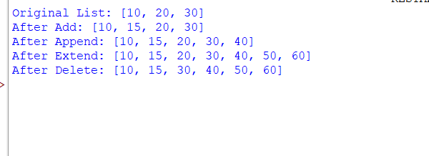

7. Write a python program to Illustrate Different Set Operations?
Aim
To write a Python program to illustrate different set operations such as union, intersection, difference, and symmetric difference.
Algorithm
- Start the program.
- Create two sets, A and B.
- Perform the union operation using |.
- Perform the intersection operation using &.
- Perform the difference operation using -.
- Perform the symmetric difference operation using ^.
- Display the results.
- Stop the program.
Python Program:
A = {10, 20, 30, 40}
B = {30, 40, 50, 60}
print("Set A:", A)
print("Set B:", B)
print("Union:", A | B)
print("Intersection:", A & B)
print("Difference (A-B):", A - B)
print("Difference (B-A):", B - A)
print("Symmetric Difference:", A ^ B)
Output: 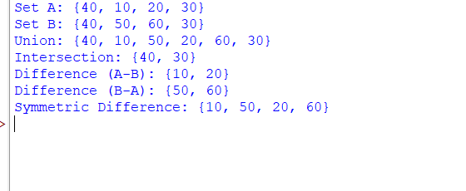
8. Write a python program to generate Calendar for the given month and year?
Aim
To write a Python program to generate a calendar for the given month and year.
Algorithm
- Start the program.
- Import the calendar module.
- Get the month and year from the user.
- Use the calendar.month() function to generate the calendar.
- Display the calendar.
- Stop the program.
Python Program:
import calendar
year = int(input("Enter year: "))
month = int(input("Enter month (1-12): "))
print(calendar.month(year, month))
Output:
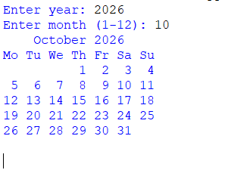
9.Write a python program to remove punctuations from the given string?
Aim
To write a Python program to remove punctuation marks from a given string.
Algorithm
- Start the program.
- Import the string module.
- Get a string from the user.
- Create an empty string to store the result.
- Check each character and remove punctuation marks.
- Display the string without punctuation.
- Stop the program.
Python Program
import string
text = input("Enter a string: ")
result = ""
for ch in text:
if ch not in string.punctuation:
result += ch
print("String without punctuation:", result)

Output:

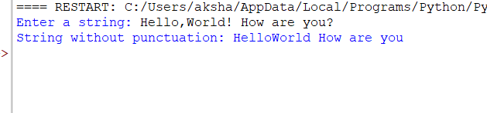

10.Write the python program to solve 8-Puzzle problem.
Aim
To write a Python program to solve the 8-puzzle problem using the A* search algorithm.
Algorithm
- Start the program.
- Define the initial state and goal state of the puzzle.
- Calculate the heuristic value using the Manhattan distance.
- Select the state with the lowest cost.
- Generate possible moves by moving the blank space up, down, left, or right.
- Repeat until the goal state is reached.
- Display the solution steps.
- Stop the program.
Python Program:
import heapq
def heuristic(state, goal):
distance = 0
for i in range(9):
if state[i] != 0:
j = goal.index(state[i])
distance += abs(i // 3 - j // 3)
distance += abs(i % 3 - j % 3)
return distance

def solve(start, goal):
pq = [(heuristic(start, goal), 0, start)]
parent = {start: None}
cost = {start: 0}
while pq:
f, g, state = heapq.heappop(pq)
if state == goal:
path = []
while state is not None:
path.append(state)
state = parent[state]
return path[::-1]
if g != cost[state]:
continue
zero = state.index(0)
row, col = zero // 3, zero % 3
moves = []
if row > 0:
moves.append(zero - 3)
if row < 2:
moves.append(zero + 3)
if col > 0:
moves.append(zero - 1)
if col < 2:
moves.append(zero + 1)

for move in moves:
new_state = list(state)
new_state[zero], new_state[move] = (
new_state[move], new_state[zero]
)
new_state = tuple(new_state)
new_cost = g + 1
if new_cost < cost.get(new_state, float("inf")):
cost[new_state] = new_cost
parent[new_state] = state
priority = new_cost + heuristic(new_state, goal)
heapq.heappush(
pq, (priority, new_cost, new_state)
)
return None
# Main program
values = list(map(int, input(
"Enter 9 numbers (0 for blank): "
).split()))
if len(values) != 9 or sorted(values) != list(range(9)):
print("Invalid input! Enter numbers 0 to 8 exactly once.")
else:
start = tuple(values)
goal = (1, 2, 3, 4, 5, 6, 7, 8, 0)
# Check whether the puzzle is solvable
numbers = [x for x in start if x != 0]
inversions = sum(
numbers[i] > numbers[j]
for i in range(8)
for j in range(i + 1, 8)
)
if inversions % 2 != 0:
print("This puzzle has no solution.")
else:
solution = solve(start, goal)
if solution:
print("Solution found in", len(solution) - 1, "moves:")
for step, state in enumerate(solution):
print("Step", step)
for i in range(0, 9, 3):
print(*state[i:i + 3])
print()
else:
print("No solution found.")
Output:

